
Airkrit India Pvt. Ltd.

New Delhi & Bengaluru
CIN - U85499DL2023PTC423549

www.airkrit.com support@airkrit.com
+91 8929252575

Letter of Recommendation
DD-MM-YYYY
Dear [Your Name]

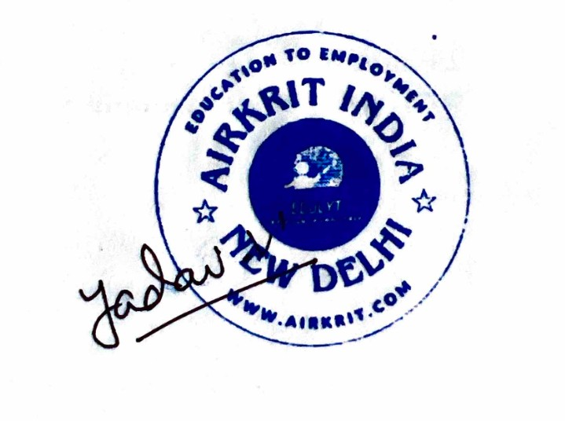
ID : AI-XXXX
TO WHOM SO EVER IT MAY CONCERN
We are pleased to recommend [Full Name], who successfully completed our technical training and/or internship program. Throughout the tenure, [he/she] showed consistent dedication, adaptability, and a strong grasp of key concepts. [His/Her] performance in both theoretical sessions and real-world project work on live data was highly commendable.

[Full Name] actively participated in mentorship sessions, responded well to feedback, and made full use of available resources, including doubt support and interview preparation workshops. These efforts reflected a genuine willingness to grow and transition confidently into the tech domain.

Based on [his/her] overall performance and attitude, we are confident [he/she] will make valuable contributions in any technical role. We fully endorse [Name] for future opportunities in the field.

[%qrImage]
Vishal Yadav – Manager HR

Airkrit India
Education to Employment

Note : Future verification can be done on verify@airkrit.com

